

# Rossmoyne Senior High School

### Semester One Examination, 2016

### Question/Answer Booklet

# MATHEMATICS

**SOLUTIONS**

**APPLICATIONS**

**UNIT 3**

## Section One:

## Calculator-free

|  |  |  |  |  |  |  |  |  |
| --- | --- | --- | --- | --- | --- | --- | --- | --- |
| Student Number: In figures |  |  |  |  |  |  |  |  |

In words

Your name

## Time allowed for this section

Reading time before commencing work: five minutes

Working time for section: fifty minutes

## Materials required/recommended for this section

***To be provided by the supervisor***

This Question/Answer Booklet

Formula Sheet

***To be provided by the candidate***

Standard items: pens (blue/black preferred), pencils (including coloured), sharpener, correction fluid/tape, eraser, ruler, highlighters

Special items: nil

## Important note to candidates

No other items may be taken into the examination room. It is **your** responsibility to ensure that you do not have any unauthorised notes or other items of a non-personal nature in the examination room. If you have any unauthorised material with you, hand it to the supervisor **before** reading any further.

## Structure of this paper

|  |  |  |  |  |  |
| --- | --- | --- | --- | --- | --- |
| Section | Number of questions available | Number of questions to be answered | Working  time (minutes) | Marks available | Percentage of exam |
| Section One:  Calculator-free | 7 | 7 | 50 | 50 | 35 |
| Section Two:  Calculator-assumed | 12 | 12 | 100 | 100 | 65 |
|  | | | **Total** | 150 | 100 |

## Instructions to candidates

1. The rules for the conduct of examinations are detailed in the school handbook. Sitting this examination implies that you agree to abide by these rules.
2. Write your answers in this Question/Answer Booklet.
3. You must be careful to confine your response to the specific question asked and to follow any instructions that are specified to a particular question.
4. Spare pages are included at the end of this booklet. They can be used for planning your responses and/or as additional space if required to continue an answer.

* Planning: If you use the spare pages for planning, indicate this clearly at the top of the page.
* Continuing an answer: If you need to use the space to continue an answer, indicate in the original answer space where the answer is continued, i.e. give the page number. Fill in the number of the question that you are continuing to answer at the top of the page.

1. **Show all your working clearly**. Your working should be in sufficient detail to allow your answers to be checked readily and for marks to be awarded for reasoning. Incorrect answers given without supporting reasoning cannot be allocated any marks. For any question or part question worth more than two marks, valid working or justification is required to receive full marks. If you repeat any question, ensure that you cancel the answer you do not wish to have marked.
2. It is recommended that you **do not use pencil**, except in diagrams.
3. The Formula Sheet is **not** to be handed in with your Question/Answer Booklet.

Section One: Calculator-free 35% (50 Marks)

This section has**seven (****7)** questions. Answer **all** questions. Write your answers in the spaces provided.

Working time for this section is 50 minutes.

Question 1 (7 marks)

(a) Re-draw the following graph to clearly demonstrate that it is planar. (3 marks)

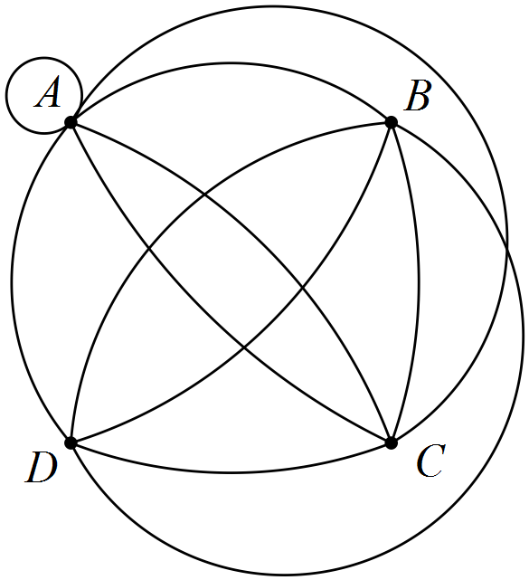

|  |
| --- |
| **Solution** |
| Tip: Remove loops and multiple edges, redraw without crossings, add loops, etc back |
| **Specific behaviours** |
| ✓ has no edges crossing  ✓ AC and BD both have three connecting edges  ✓ correct equivalent graph |

(b) Draw a complete graph with five vertices. (2 marks)

|  |
| --- |
| **Solution** |
|  |
| **Specific behaviours** |
| ✓ draws graph with five vertices  ✓ connects each vertex to all others |

(c) Do **all** complete graphs obey Euler's formula? Justify your answer. (2 marks)

|  |
| --- |
| **Solution** |
| No - complete graphs with more than 4 vertices are not planar and Euler's rule only applies to connected planar graphs. |
| **Specific behaviours** |
| ✓ states no  ✓ states valid reason |

Question 2 (8 marks)

The scatterplot below, with least-squares line displayed, shows the relationship between two numerical variables, x and y. The correlation coefficient between the variables is 0.92.

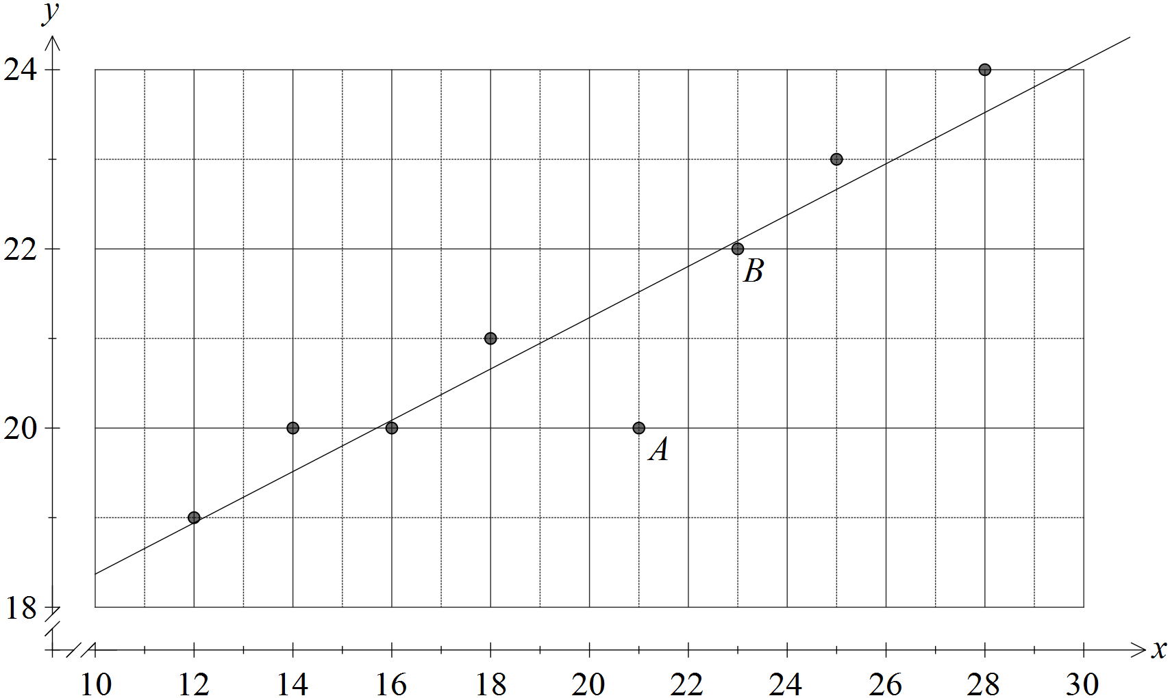

(a) Describe the association between x and y in terms of direction and strength.

(2 marks)

|  |
| --- |
| **Solution** |
| Strong, positive association |
| **Specific behaviours** |
| ✓ states positive direction  ✓ states moderate to strong strength |

(b) Describe the effect on the correlation coefficient if

(i) the point labelled A was removed from the dataset. (1 mark)

|  |
| --- |
| **Solution** |
| Coefficient would increase, becoming closer to 1. |
| **Specific behaviours** |
| ✓ states increase |

(ii) the point labelled B was removed from the dataset. (1 mark)

|  |
| --- |
| **Solution** |
| Coefficient would decrease, becoming closer to 0. |
| **Specific behaviours** |
| ✓ states decrease |

(c) Sketch a residual plot for the eight paired values on the axes below. (3 marks)

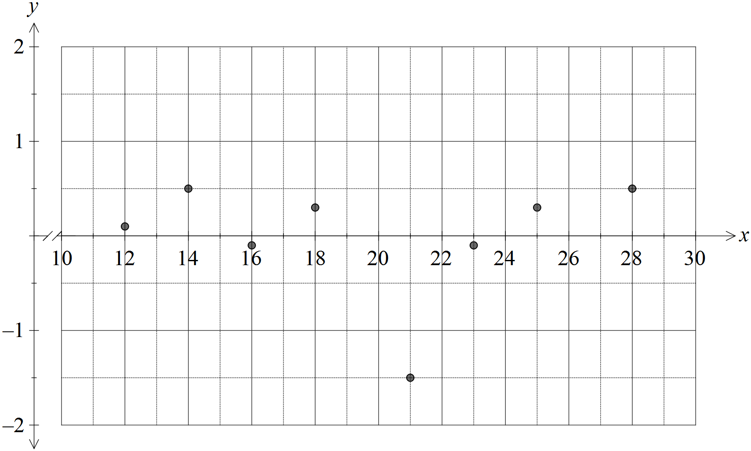

|  |
| --- |
| **Solution** |
| See graph - allow some latitude for estimating residuals by eye |
| **Specific behaviours** |
| ✓ plots at least 6 residuals above or below x-axis, as appropriate  ✓ magnitude of at least 6 residuals approximately correct  ✓ plots all residuals correctly |

(d) Comment, with reasons, on the appropriateness of fitting a linear model to this dataset.

(1 mark)

|  |
| --- |
| **Solution** |
| Linear model is appropriate because no pattern is evident in the residuals. |
| **Specific behaviours** |
| ✓ states appropriate with reason |

Question 3 (6 marks)

(a) Three hikers were sharing tips about walking on four famous routes. Ahn had walked the Inca Trail, Kilimanjaro and the Snowman Trek. Bi had walked the Inca Trail, Kilimanjaro and the Overland Track. Chris had walked the Overland Track and the Snowman Trek.

Display this information as a bipartite graph. (2 marks)

|  |
| --- |
| **Solution** |
|  |
| **Specific behaviours** |
| ✓ displays two sets of vertices  ✓ joins vertices correctly |

(b) A bipartite graph is shown below, joining vertices in two disjoint sets. Clearly list the vertices belonging to each of the two sets. (2 marks)

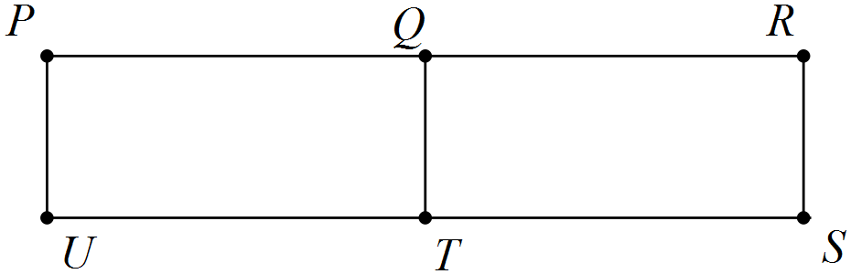

|  |
| --- |
| **Solution** |
| Sets are {P, T, R} and {U, Q, S} |
| **Specific behaviours** |
| ✓ redraws graph  ✓ lists both sets |

(c) A complete bipartite graph has six vertices. Determine the smallest possible number of edges. (2 marks)

|  |
| --- |
| **Solution** |
| Answer: 5 edges |
| **Specific behaviours** |
| ✓ sketches possible graphs  ✓ states correct minimum number |

Question 4 (8 marks)

The terms of a sequence are shown in the graph below.

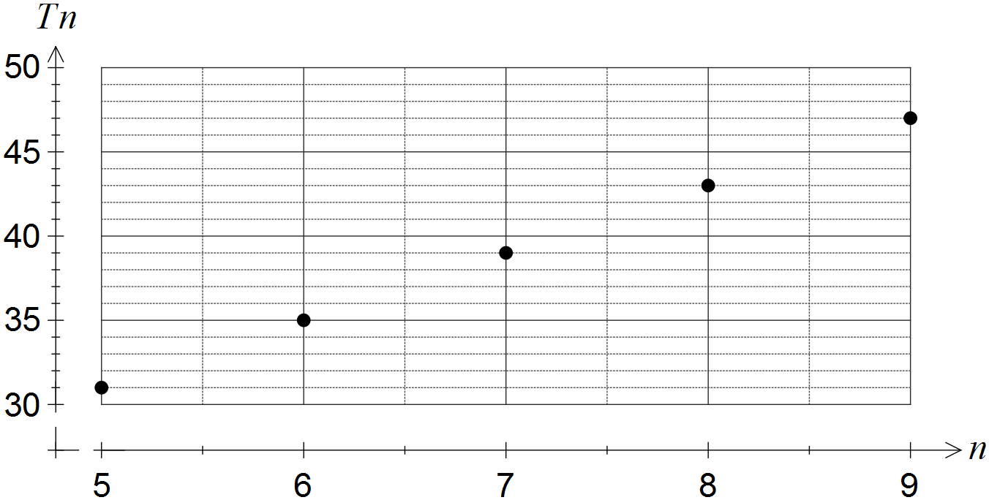

(a) Choose the best description of the sequence from geometric, arithmetic or neither, explaining your choice. (2 marks)

|  |
| --- |
| **Solution** |
| Arithmetic - the terms have a constant difference of 4. |
| **Specific behaviours** |
| ✓ chooses arithmetic  ✓ refers to constant difference between consecutive terms |

(b) Determine

(i) . (1 mark)

|  |
| --- |
| **Solution** |
|  |
| **Specific behaviours** |
| ✓ determines correct value |

(ii) . (1 mark)

|  |
| --- |
| **Solution** |
|  |
| **Specific behaviours** |
| ✓ determines correct value |

(c) Deduce a rule for the nth term of the sequence, simplifying your answer. (2 marks)

|  |
| --- |
| **Solution** |
|  |
| **Specific behaviours** |
| ✓ determines general rule  ✓ expands and simplifies rule |

(d) Determine the value of n such that . (2 marks)

|  |
| --- |
| **Solution** |
|  |
| **Specific behaviours** |
| ✓ writes equation  ✓ solves equation |

Question 5 (7 marks)

The edges in the graph below represent the roads in a park that meet at the given vertices.

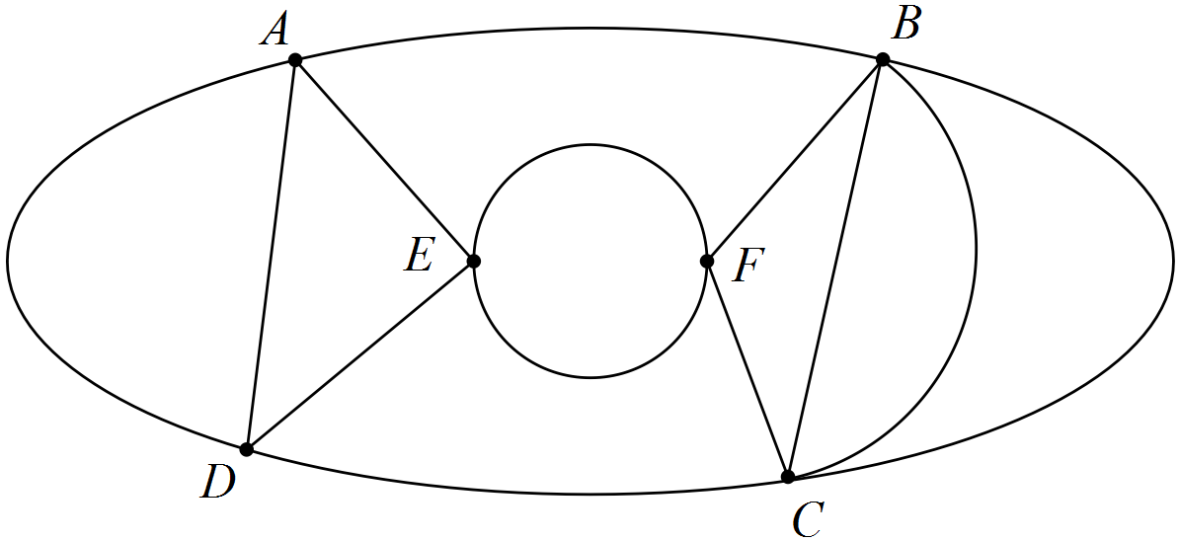

(a) Show that Euler's formula applies to this graph. (2 marks)

|  |
| --- |
| **Solution** |
|  |
| **Specific behaviours** |
| ✓ states correct values for edges, vertices and faces  ✓ substitutes into Euler's formula correctly |

(b) Record the degree of each vertex shown in the graph in the table below. (2 marks)

|  |  |  |  |  |  |  |
| --- | --- | --- | --- | --- | --- | --- |
| Vertex | A | B | C | D | E | F |
| Degree | **4** | **5** | **5** | **4** | **4** | **4** |

|  |
| --- |
| **Solution** |
| See table |
| **Specific behaviours** |
| ✓ at least five correct  ✓ all six correct |

(c) Without referring to the information in (b), clearly explain why the graph is semi-Eulerian. (2 marks)

|  |
| --- |
| **Solution** |
| The graph is semi-Eulerian because it contains an open (rather than closed) trail that includes each edge just once. |
| **Specific behaviours** |
| ✓ states trail using all edges just once  ✓ states trail is open  *NB Do not accept explanations based on degree of vertices* |

(d) A park ranger has to inspect every road in the park. List all possible starting points so that the ranger can complete this task without driving on the same road more than once.

(1 mark)

|  |
| --- |
| **Solution** |
| B or C |
| **Specific behaviours** |
| ✓ states both possible solutions |

Question 6 (5 marks)

The scatterplot below shows data from a sample of towns in a region.

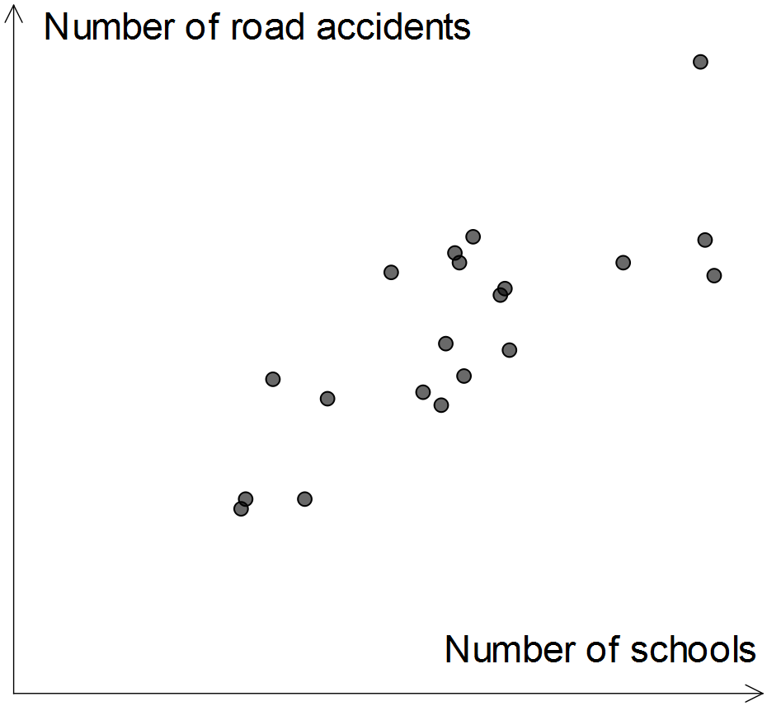

(a) Which of the numbers 1, -1, 0.75, -0.75, 0.5, -0.5, 0.25, -0.25 and 0 is closest to the correlation coefficient between the two variables? Explain your choice. (2 marks)

|  |
| --- |
| **Solution** |
| 0.75  The association is moderate to strong and positive |
| **Specific behaviours** |
| ✓ chooses 0.75  ✓ supplies reason using strength and direction |

(b) A politician saw the graph and claimed the data supported his plan to merge small schools and hence reduce the number of schools in individual towns. Identify a reason the politician might have had to make such a claim. (1 mark)

|  |
| --- |
| **Solution** |
| The plot shows that towns with fewer schools have fewer road accidents |
| **Specific behaviours** |
| ✓ states reason supported by scatterplot |

(c) Identify and explain a possible non-causal explanation for the observed association between the number of schools and the number of road accidents in this sample of towns. (2 marks)

|  |
| --- |
| **Solution** |
| The size of individual towns is likely to be a confounding variable. The two variables are both likely to have a causal association with town size, but not with each other. |
| **Specific behaviours** |
| ✓ states town size, or other plausible confounding variable  ✓ explains confounding due to common response to third variable |

Question 7 (9 marks)

(a) A connected planar graph has one face and three edges.

(i) Determine the number of vertices the graph has. (2 marks)

|  |
| --- |
| **Solution** |
|  |
| **Specific behaviours** |
| ✓ uses Euler's formula  ✓ states correct number |

(ii) Sketch a graph with these properties. (2 marks)

|  |
| --- |
| **Solution** |
|  |
| **Specific behaviours** |
| ✓ sketches a tree  ✓ sketch has all other required properties |

(b) Consider the graph below.

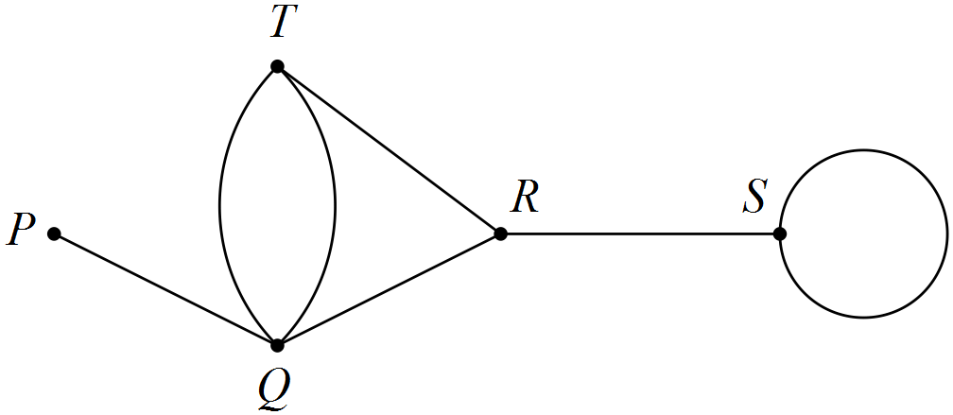

State the length of the longest possible walk in this graph and list, in order from first to last, the vertices visited, so that the walk

(i) is an open trail. (2 marks)

|  |
| --- |
| **Solution** |
| PQTQRSS - length 6 |
| **Specific behaviours** |
| ✓ lists vertices with no edges repeated, starting and finishing at different vertices  ✓ states correct length |

(ii) is a closed path. (3 marks)

|  |
| --- |
| **Solution** |
| QRTQ (or similar cycle) - length 3 |
| **Specific behaviours** |
| ✓ lists vertices with no repeats, except for first and last, and no edges repeated  ✓ start and finish at same vertex  ✓ states correct length |

Additional working space

Question number: _________

© 2016 WA Exam Papers. Rossmoyne Senior High School has a non-exclusive licence to copy and communicate this paper for non-commercial, educational use within the school. No other copying, communication or use is permitted without the express written permission of WA Exam Papers.